Registration ID: 11614284
Email ID : malhotraruvaina@gmail.com
GitHub:
Problem: Question 8 : Round Robin Scheduling

Code:
#include<stdio.h>
#include<stdlib.h>

void get ()
{

int t, id[t], bt[t], wt[t], tat[t], p[t], i, j, a;

printf("************WELCOME**************\n");

printf ("\nEnter the total no. of processes: ");

scanf ("%d", &t);

for (i = 0; i < t; i++)

{

printf ("Enter id of process %d: ", i + 1);

scanf ("%d", &id[i]);

printf ("Enter burst time of process %d: ", i + 1);

scanf ("%d", &bt[i]);

printf ("Enter priority of process %d: ", i + 1);

scanf ("%d", &p[i]);

}

for (i = 0; i < t; i++)

{

for (j = i + 1; j < t; j++)

{

if (p[i] > p[j])

{

a = p[i];

p[i] = p[j];

p[j] = a;

a = bt[i];

bt[i] = bt[j];

bt[j] = a;

a = id[i];

id[i] = id[j];

id[j] = a;

}

}

wt[i] = 0;

}

for (i = 0; i < t; i++)

{

for (j = 0; j < i; j++)

{

wt[i] = wt[i] + bt[j];

}

tat[i] = wt[i] + bt[i];

}

float avwt = 0, avtat = 0;

printf ("Process\tP\tBT\tWT\tTAT\n");

for (i = 0; i < t; i++)

{

printf ("%d\t%d\t%d\t%d\t%d\n", id[i], p[i], bt[i], wt[i], tat[i]);

avwt = avwt + wt[i];

avtat = avtat + tat[i];

}

avwt = avwt / t;

avtat = avtat / t;

printf ("\nAverage Turnaround Time is: %f", avtat);

printf ("Average Waiting Time is: %f\n", avwt);

}

main ()
{
get();

}
Constraints:
1.Time quantum is fixed ie 10.
2.Atleast one process is required .
3.Processes cannot be taken as negative.

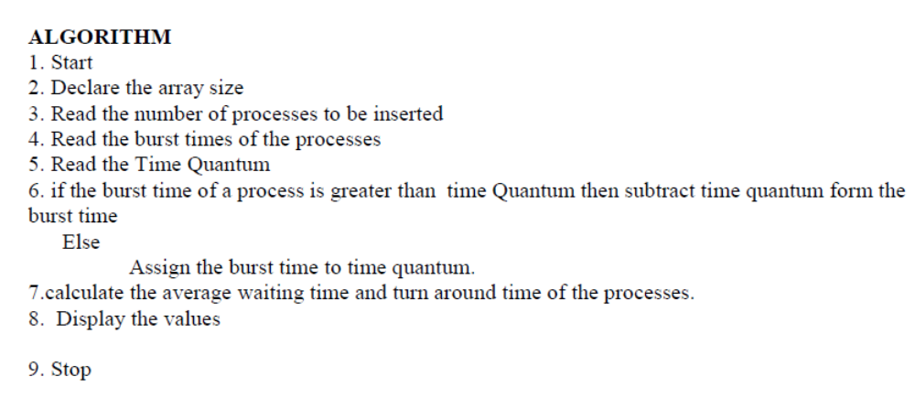

SCREENSHOT OF THE OUTPUT
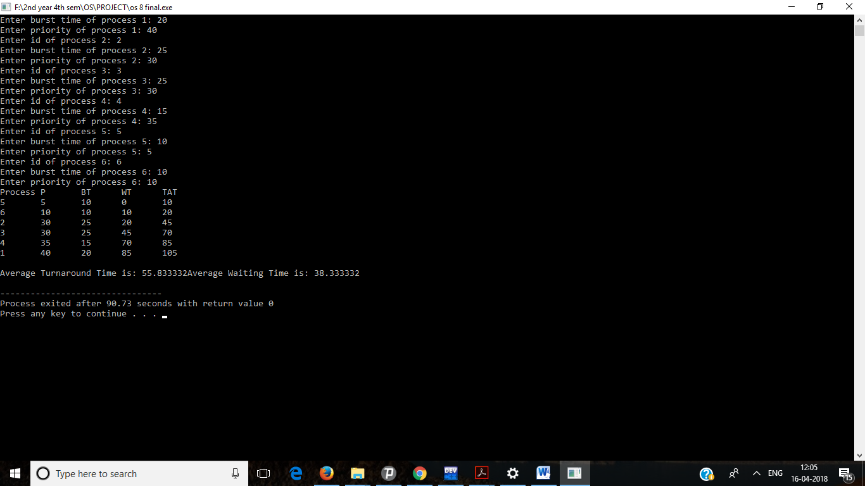

Problem: Q 19

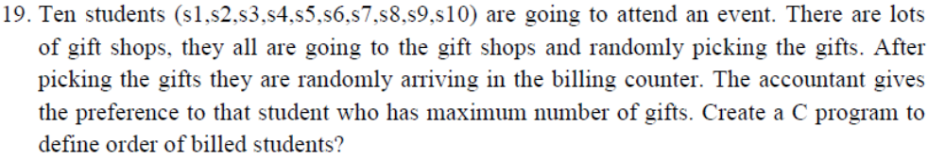

Constraints:
1. The number of students entered should be 10.
2. Negative values should not be entered.
3. No floating point values should be entered.

Algorithm:
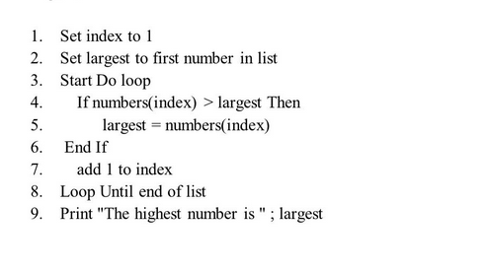

Code:
#include<stdio.h>
#include<conio.h>

struct gifts
{
char st;
int n,gif;
}s[10];

main()
{
printf("*******************************WELCOME TO THE PROGRAMME**********************************\n");
int j,k,tmp;
for(j=0;j<10;j++)
{
s[j].st='s';
s[j].n=j+1;
}
printf("\nEnter the gifts taken by students one by one\n");
for(j=0;j<10;j++)
{
printf("\nGifts taken by Student %c%d : ",s[j].st,s[j].n);
scanf("%d",&s[j].gif);
}

for(k=0;k<9;k++)
for(j=0;j<9-k;j++)
{
if(s[j].gif<s[j+1].gif)
{
tmp=s[j].gif;
s[j].gif=s[j+1].gif;
s[j+1].gif=tmp;
}
}
printf("\nOrder in which billing will be processed is:\n");
for(j=0;j<10;j++)
{
printf("\n %c%d : %d",s[j].st,s[j].n,s[j].gif);
}
}

SCREENSHOT OF THE OUTPUT
